3)
gen list = 13.06
Gen tree = 2.25
4)
Gen list = 5.94
Gen tree = 2.21
5)
A bad alg with structed optimization is way faster!
6)
a) Objdump -t assign1-0
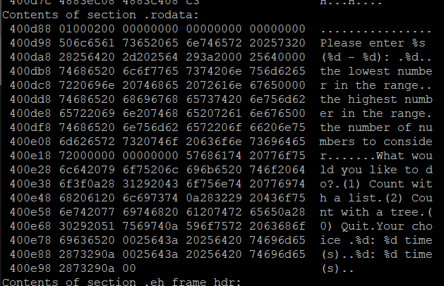

b) Objdumb -d assign1-0
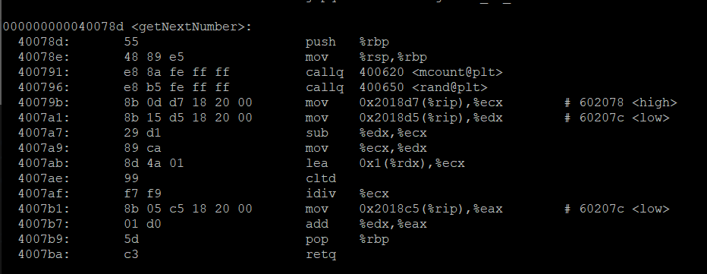

c) Objdumb -s assign1-0

d) cant find tree pointer because it is hidden somewhere in the stack. Doesn’t have a variable like the other variables it is a reference so its hiding until someone uses it.

7)
In my own code there must be some way to do a while loop instead of writing the user prompt code twice. I tried messing around with it but I couldn’t fin a way to code it.
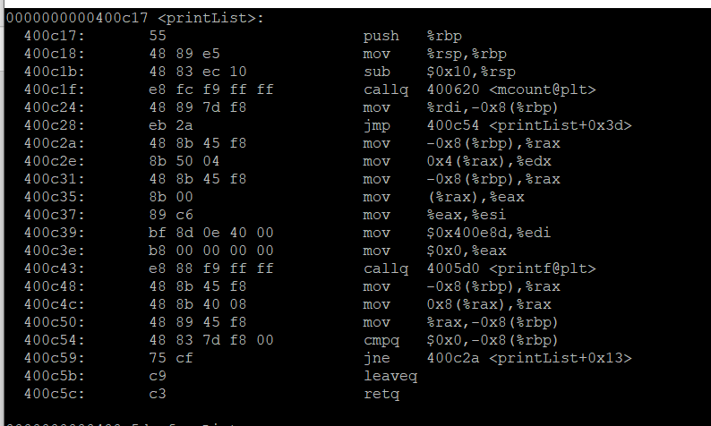There are a lot of movs in print list and although is might be exponentially faster. A lot of these moves can turn into push and pops I am just not sure which ones looking at the code.

